Instructions
Memes provide rhetors on the Internet with a visually engaging device for generating discussion. For our course review (Monday, March 8), you will create and present a meme on a film screened in class. Your meme must capture themes discussed in class (masculinity, virility, male crises, etc.). You may choose the film/ film protagonist you would like to ‘meme’ within your group of 6. However, you may not ‘meme’ the film/ film protagonist you presented for your scene analysis. In addition to creating a ‘meme,’ you should prepare some notes to explain your ‘meme,’ referencing class readings and discussions. You’ll share your ‘meme’ with your group and with the class.

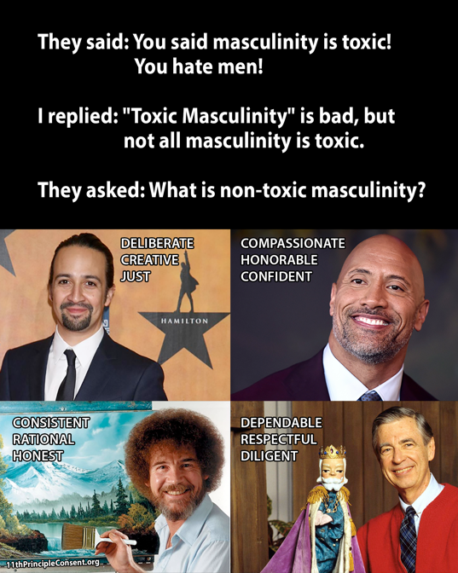


Examples

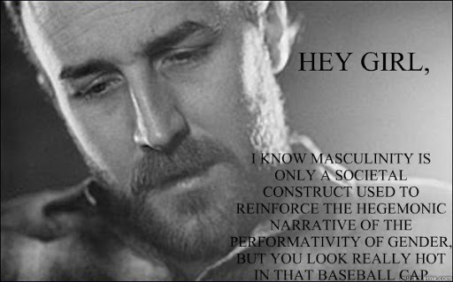

Technology
You may use technology/resources you are familiar with; however, I would encourage you to use Canva (https://www.canva.com/). Canva is a free graphic design platform that provides templates and uses a simple drag and drop interface.

Films
Una giornata particolare / A Special Day (Ettore Scola, 1977)

Il conformista / The Conformist (Bernardo Bertolucci, 1970)

Ladri di biciclette / Bicycle Thieves (Vittorio De Sica, 1948)

Ieri, oggi, domani / Yesterday, Today, and Tomorrow (Vittorio De Sica, 1963)

Sedotta e abbandonata / Seduced and Abandoned (Pietro Germi,1964)

I cento passi / One Hundred Steps (Marco Tullio Giordana, 2000)

