PART I: BEFORE VIEWING
Una giornata particolare- A Special Day (look up missing info on IMDb)
Director:___________________
Year: 1977

Cast
Character Actor/ Actress
Antonietta Taberi
Gabriele
Emanuele Taberi

1) Analyze the film poster. Who do you imagine the characters to be (occupations, relations/ interrelations, challenges/ solutions)? What do you think A Special Day will be about? What might be the significance of the film title? Write a minimum of 7 sentences.

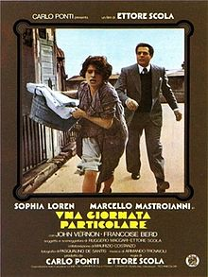

PART II: WHILE VIEWING

1) Pick one technique/element to focus on: music/sound, camerawork, symbolism/iconography. Describe how this technique/element is used in one scene. Be sure to jot down the minutes so you can re-view it and expand upon this response after viewing the film in its entirety. Write a minimum of 10 sentences.

PART III: After Viewing

1) A Special Day opens with a lengthy segment of archival footage of Hitler’s visit with Mussolini on May 6, 1938. The film then transitions into a fictional account of a day passed between two neighbors. What might be the significance of this artistic choice (integrating archival footage into fiction)? Might it be related in some way to the significance of the title? Which ‘special day’ might the title refer to? Write 5-7 sentences.

2) Nearly the entire film takes place in an apartment complex. What might be the significance of this setting? Is it correlated in some way with the co-protagonists’ qualities/behaviors/intrapersonal struggles? Do you notice differences in their comportments in inside vs. outside spaces? Write 7-10 sentences.

3) How is masculinity depicted in this film? Are competing notions of masculinity present? Describe specific characters and scenes. Do you find any of these representations of masculinity surprising? Why or why not? (keep in mind the historical context) Write a minimum of 7 sentences.

