PART I: BEFORE VIEWING
Città delle donne/ City of Women (look up missing info on IMDb)
Director:___________________
Year:

Cast
Character Actor/ Actress Snàporaz
Elena
Woman on train
Motorcyclist
Donatella
Dr. Xavier Katzone
Oliver Hardy

1) Analyze the film poster. Who do you imagine the characters to be (occupations, relations/interrelations, challenges/solutions)? What do you think City of Women will be about? What might be the significance of the film title? Write a minimum of 5 sentences.

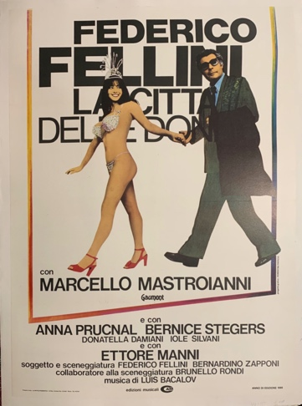

PART II: WHILE VIEWING

1) Pick one technique/element to focus on: music/sound, camerawork, symbolism/iconography. Describe how this technique/element is used in one scene. Be sure to jot down the minutes so you can re-view it and expand upon this response after viewing the film in its entirety. Write a minimum of 10 sentences.

PART III: After Viewing

1) Reich claims that “City of Women address head on Fellini’s own self-professed fear and bewilderment around women, which he foregrounds in light of Italy’s [then] recent feminist movement” (“Stars, Gender, and Nation,” p. 55) and that “despite its phallic iconography, images of impotence abound” in this film (“Stars, Gender, and Nation” p. 58).

Film critic Roger Ebert avers:

City of Women does nothing original or very challenging with this material. Although it pretends to be Fellini's film about feminism, it reveals no great understanding of the subject; Fellini basically sees feminists as shrill harems of whip-wielding harridans, forever dangling the carrot of sex just out of reach of his suffering hero. Fellini has rarely been able to discover human beings hidden inside his female characters, and it's a little late for him to start blaming that on the women's liberation movement. (https://www.rogerebert.com/reviews/city-of-women-1981)

Do you agree? Cite examples from the film as well as relevant points from class discission and the Playboy interview with Fellini. Write at least 7-10 sentences.

2) What role does humor play in dismantling/ subverting conventions of masculinity/ femininity in this film? Could the same message/ critique be portrayed without humor? How would the film change? Write 7-10 sentences.

3) Do you think the title, City of Women, does justice to the film (think about the content/ interpersonal relationships)? Create an alternate title for the film. Explain why you think this title would be appropriate. Write a minimum of 5 sentences.

