PART I: BEFORE VIEWING
Il conformista/ The Conformist (look up missing info on IMDb)
Director:___________________
Year:

Cast
Character Actor/ Actress
Marcello Clerici
Giulia (Marcello’s fiancé)
Marcello’s mother
Marcello’s father
Italo Montanari
Manganiello
Lino
Anna Quadri
Professor Quadri

- In a 1973 interview published in Rolling Stone, Jonathan Cott describes The Conformist as “a film about a sexually repressed Italian fascist who is ordered to kill his former professor, now an anti-fascist leader in Paris.” Cott then asks Bertolucci to comment on the “sometimes confusing” intersection of sexuality and politics in his films. Bertolucci responds with the following claim:
[…] I think the average man is fascistic. All my characters are average persons who are conscious of being average, and they’re made uncomfortable by being aware of this.

Reflecting on Bertolucci’s comment, the time period during which The Conformist is set, as well as the film title, what kinds of struggles/conflicts do you anticipate the film protagonist will encounter? Write 5-7 sentences.

PART II: WHILE VIEWING

1) Pick one technique/element to focus on: music/sound, camerawork, symbolism/iconography. Describe how this technique/element is used in one scene. Be sure to jot down the minutes so you can re-view it and expand upon this response after viewing the film in its entirety. Write a minimum of 10 sentences.

PART III: After Viewing

1) The Conformist puts forth a series of potential father figures for the protagonist. What behaviors/ model(s) of masculinity does each father figure represent? Write a few notes for each character, and provide specific examples when possible.

- Biological father

- Italo Montanari

- Lino

- Priest

- Manganiello

- Professor Quadri

- There is a reference to Plato’s Allegory of the Cave in exchange between Marcello (a fascist functionary) and Professor Quadri (his former professor & an anti-fascist activist) [55.26-57.50].

Plato’s “Allegory of the Cave”: A Philosophical Rumination on Believes vs. Reality

The allegory states that there exist prisoners chained together in a cave. Behind the prisoners is a fire, and between the fire and the prisoners are people carrying puppets or other objects. This casts a shadow on the other side of the wall. The prisoners watch these shadows, believing them to be real.
Plato posits that one prisoner could become free. He finally sees the fire and realizes the shadows are fake. This prisoner could escape from the cave and discover there is a whole new world outside that they were previously unaware of.
This prisoner would believe the outside world is so much more real than that in the cave. He would try to return to free the other prisoners. Upon his return, he is blinded because his eyes are not accustomed to actual sunlight. The chained prisoners would see this blindness and believe they will be harmed if they try to leave the cave. (from: https://www.studiobinder.com/blog/platos-allegory-of-the-cave/).
Check out Alex Gendler’s TED Ed talk on Plato’s “Allegory of the Cave”
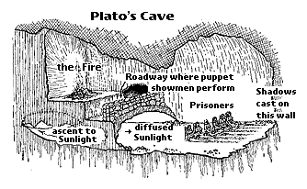

Figure from: https://faculty.washington.edu/smcohen/320/cave.htm

What is the significance of this reference? Is the fascist vs. antifascist relation between the two characters important? What about the former student- [failed] professor dynamic? What about Marcello’s obsession with ‘normality’? In addition to the aforementioned exchange between Marcello and Professor Quadri, think about the conclusion to The Conformist (when Marcello breaks the fourth wall and stares into the fire). Write 7-10 sentences.

- The Conformist is recounted via flashbacks, asynchronous sequences, and analepses. This combination of techniques breaks from conventions of narrative cinema. Keep in mind that present (recounted in the long ‘car sequence’) is continuously interrupted by flashbacks, flashbacks within flashbacks, and incidents of ellipses, yet time and the present-day storyline continue to progress. What might be the purpose of this fragmented, non-linear narration? Might it be related to Marcello? Might it be an artistic commentary on ‘male crises’? On fascism? On conventions of narrative film? Write 7-10 sentences.

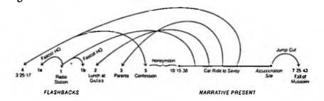

Figure from Marcus, “Bertolucci’s The Conformist: A Moral’s Guide,” p. 294

